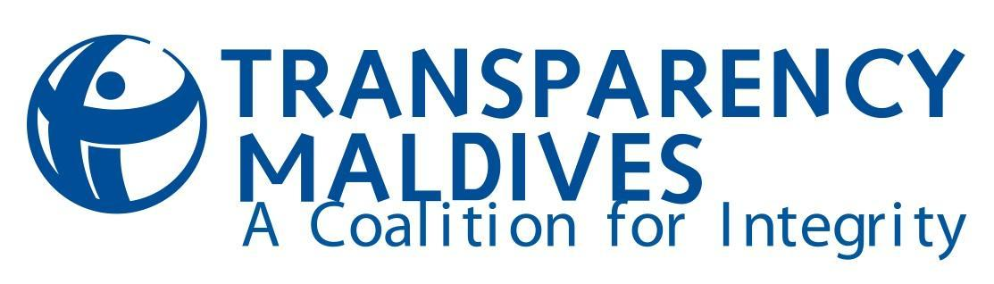
TERMS OF REFERENCE

Research Consultancy
Review of the Decentralization Framework in the Maldives

Position title: Research Consultant
Research title: Review of Decentralization Framework in the Maldives
Expected period of commitment: approximately 8 weeks
Application deadline: 17th August 2016
Location: Malé, Maldives

1. Organization Background
Transparency Maldives (TM) is a non-partisan organization that endeavors to be a constructive force in society by promoting collaboration and discussion on corruption, transparency and accountability. Our organization seeks to engage with stakeholders from all sectors (government, business, politics and civil society, among others) to raise awareness of corruption’s detrimental effects on development and society, improve transparency and accountability in governance, and eliminate corruption from the daily lives of people.

Transparency Maldives received formal government registration in 2007, and is the National Contact of Transparency International (TI) in the Maldives.

2. Background to the Assignment
TM’s “Baaru” project (Strengthening local governance in the Maldives through capacity building local councils and empowering citizens for social accountability) is a 3-year project funded by the European Union (EU). The goal of the project is to strengthen local democracy and the decentralization system in the Maldives.
The passing of the new Constitution in 2008 and the enactment of the Decentralization Act in 2010 saw a considerable policy shift to devolve previously centralized power to local communities. However, policy discussions around the decentralization framework before and after the Decentralization Act came into force has been deeply divided along party lines, often at the cost of meaningful policy discussion. As a result, meaningful devolution of power and by extension, empowering of local island communities have not taken place.
Furthermore, the functioning of the local government system and the authority of councils are threatened by the increasing trends towards centralization. Following the passage of the Special Economic Zone (SEZ) Act in 2015 and a number of procedural changes that have been observed through regulation and practice, there is limited understanding on how these changes affect local communities and the principles of decentralization of power.
One of the key activities under the project is to conduct a comprehensive review of the decentralization framework with a reflection of Maldives’ experience with decentralization in order to inform future policy conversations around decentralization and strengthen the local governance system in the Maldives.
3. Purpose of the Assignment
TM is seeking the services of a research consultant to produce a comprehensive review of the decentralization framework. The review will reflect on the historical development of decentralization and the experience with decentralization since 2010, examine the legal, structural and practical challenges in local governance, and provide policy recommendations for reform and strengthening the decentralization framework.

This review will be a key advocacy and policy tool at the regional workshops and annual symposiums on local governance. This review will further help inform the creation of the Local Councils Associations or Union that will be established during the project period. This association or union will serve as a platform to organize local governments and mobilize local councils for collective action in order to positively influence policy decisions concerning local governance. A communications and advocacy plan comprising of a press conference, appearance on current affairs programs, social media and shareable graphics will also be rolled out to disseminate the findings and recommendations of the review to the public. The consultant will help identify target audiences and develop key messages for each.

4. Responsibilities of the consultant:
The consultant will be expected to work closely with the Senior Project Coordinator for this project to:
- Undertake a desk review of existing literature pertaining to decentralization in the Maldives.
- Provide a methodology for the review.
- Identify key stakeholders and conduct interviews and focus group discussions with relevant stakeholders
- Compile data and information on legal, structural, procedural changes related to decentralization and local governance and practical challenges to local governance
- Write the comprehensive review report
- Prepare a summary of the report with recommendations
- Produce a communications and advocacy plan to disseminate the findings of the review
- Facilitate a multi-stakeholder validation workshop to validate the findings of the report

5. Deliverables
- Submit a timeline for the deliverables, not exceeding 8 weeks.
- Detailed document with proposed methodology and report outline, along with a list of stakeholders to be interviewed.
- Report reviewing the legal and structure of decentralization and procedural changes affecting the decentralization system and practical challenges to local governance together with recommendations for policy and procedural reform based on best practices.
- Presentation to TM staff on the findings of the review.
- Conduct a stakeholder workshop to disseminate findings.
- Summary of the review report with recommendations.
- Communications and advocacy plan to disseminate the findings of the report.

6. Duration of the Assignment: Eight (8) weeks, with expected start date in August 2017. The consultant must be based in Malé, Maldives for the duration of the assignment.

7. Reporting
The Consultant will work closely with and report to the Senior Project Coordinator at TM throughout the assignment.

8. Required Competencies
- Master’s degree in a social science or related field, political science or public policy will be an advantage
- Proven expertise in political-institutional analysis with particularly strong knowledge of local governance and decentralization.
- Familiarity with concepts of good governance including transparency, accountability, and anti-corruption.
- Familiarity with quantitative and qualitative research methodologies
- Ability to research, analyze and synthesize information for a non-technical audience.
- Proven ability to clearly and concisely express ideas and concepts in written and oral form.
- Excellent spoken and written English, knowledge of Dhivehi will be an advantage
- Excellent ability to set priorities and manage time.

TM will evaluate applications based on the following criteria:
- Demonstrated familiarity with key concepts of decentralization and good governance 30%
- Budget 25%
- Qualification of key personnel 15%
- Organizational/Individual relevant experience 15%
- Proposed Timeline 15%

Closing date for applications: 04: 30pm Thursday, 17th August 2016.

Application and selection procedures: Interested applicants should submit an email to Ali Shareef (alishareef@transparencymaldives.org). The subject line must read “Research Consultancy - Decentralization Review”.

The content of the application must include the following:

- A summary of relevant experience (attach a brief CV, providing evidence that you are qualified to undertake this assignment).
- At least two examples of similar assignments that you have undertaken, preferably in the Maldives, over the past 5 years.
- Proposed charges (including estimates of consulting days and expenses)
- Two relevant references.

Applications must be in English. Only short-listed candidates will be contacted.

The contract will be awarded on a lump sum/fixed cost basis. The application should state the bid amount (in MRF) for undertaking the work.

Transparency Maldives retains the right to reject any or all of the applications and/or to enter into additional negotiations with one or more of the tendering parties to help define the exact scope of the work and deliverables to be undertaken.

An information session will be held on Sunday, 13th August 2017 @3:00 pm

Venue:
Transparency Maldives
G. Liverpool North Shabnam Magu (road opposite the mosque in front of Galolhu Stadium)
Phone: 330 4017

RSVP
please email Ali Shareef (ali.shareef@transparencymaldives.org) with the subject “Info Session”

