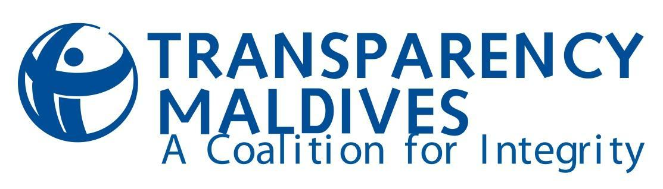
TERMS OF REFERENCE

Local Governance Training Manual Development
Consultant

Position title: Consultant - Development of Governance Training Manual
Expected period of commitment: 05 Weeks
Application deadline: Monday, 21st August 2017
Location: Male’, Maldives

1. Organization Background
Transparency Maldives (TM) is a non-partisan organization that endeavors to be a constructive force in society by promoting collaboration and discussion on corruption, transparency and accountability. Our organization seeks to engage with stakeholders from all sectors (government, business, politics and civil society, among others) to raise awareness of corruption’s detrimental effects on development and society, improve transparency and accountability in governance, and eliminate corruption from the daily lives of people.

Transparency Maldives received formal government registration in 2007, and is the National Contact of Transparency International (TI) in the Maldives.

2. Background to the Assignment

TM’s “Baaru” project (Strengthening local governance in the Maldives through capacity building local councils and empowering citizens for social accountability) is a 3-year project funded by the European Union (EU). The goal of the project is to strengthen local democracy and the decentralization system in the Maldives.

Following the contentious 2013/2014 electoral cycle in the Maldives, the marked decline in the local democratic culture, and the lack of political accountability at both the national and local level, public trust in democratic institutions have decreased and cynicism and disillusionment with democracy and the political status quo has increased. For the long-term viability of democracy in the Maldives, a multi-pronged approach is now needed to ensure a local democratic culture, an empowered citizenry, and an open and inclusive local governance system.

The broader objective of this program is to support and strengthen local governance systems using a multi-pronged focus on local government authorities and citizens to deepen democracy and enhance citizen participation in democratic processes to empower citizens for social accountability. The project aims to strengthen trust and dialogue between citizens and local governments, and empower local governments to act as catalysts for development and positive change in the communities they serve.

As one of its key components, this project focuses on capacity building local governments through trainings to equip them with knowledge and tools to improve community engagement and service provision. In this regard, we will be conducting a 3-day training for the newly elected councilors.

3. Purpose of the Assignment
Following the 2017 Local Council Elections, a new pool of councilors have been elected to local councils and there are limited institutions to provide training for these newly elected local councilors. Although the Local Government Authority (LGA) conducts orientation programs for newly elected local councilors there is room for a more comprehensive training focusing on leadership, good governance standards and practices, budgeting, island development planning, community participation and resource mobilization. This would serve to complement the ongoing orientation program provided by the LGA.

TM is seeking the services of a consultant to produce a comprehensive training manual for local councilors focussing on leadership, good governance standards and practices, budgeting, island development planning, community participation and resource mobilization and anti-corruption, and complement the training developed by the LGA to train the newly elected batch of local councilors.

The consultant is expected to assess the existing training materials and the decentralization framework, and develop a training manual for local councilors’ training. The training manual will consist of three main components: (1) the trainer’s manual, (2) the handbook for local councilors, and (3) the training assessment toolkit.

4. Responsibilities of the consultant

The Consultant will be expected to:
- Undertake a desk review of existing literature pertaining to local governance and trainings in the country.
- Identify key stakeholders and conduct interviews with stakeholders to identify training needs and gaps in existing trainings.
- Develop a training manual for master trainers which would include presentations, session outlines, notes and background reading.
- Develop a handbook for local councilors to complement existing resources, with specific focus on good governance, anti-corruption and participatory development planning and implementation.
- Develop an assessment toolkit, which includes (1) an evaluation to be administered both at the beginning and end of trainings to measure the impact of training and (2) data analysis tool to analyze data, for the Training of Trainers (ToT) and the trainings for councilors.
- Conduct ToT for master trainers.
- Collate feedback from the participants of the ToT and finalize training manual and local councilors’ handbook.

5. Deliverables
- Submit a timeline for the deliverables, not exceeding 5 weeks (in English or Dhivehi).
- A 5-page brief outlining the training areas, and how it complements existing resources in the field (in English or Dhivehi).
- Produce and deliver a final training manual (in Dhivehi).
- Develop the local councilor’s handbook (in Dhivehi).
- Conduct a ToT based on the training manual.
- Develop and deliver an assessment and data collection toolkit for the training.

6. Duration of the Assignment: Five (5) weeks, with expected start date in August 2017. The consultant must be based in Malé, Maldives for the duration of the assignment.

7. Reporting
The Consultant will work closely with and report to the Senior Project Coordinator at TM throughout the assignment.

8. Required Competencies
- Bachelor’s or a Master’s degree in a social sciences or related field.
- Proven ability to clearly and concisely express ideas and concepts in written and oral form.
- Familiarity with concepts of good governance including transparency, accountability and anti-corruption.
- Ability to research, analyze and synthesize information.
- Experience in developing training programmes for adults.
- Knowledge of decentralization framework and issues in the Maldivian context.
- Excellent spoken and written English and Dhivehi.
- Excellent ability to set priorities and manage time.
- Excellent facilitation skills

Closing date for applications: 04:30 pm on Monday, 21st August 2017.

Application and selection procedures: Interested applicants should submit an email to Shifu Omar (shifu@transparencymaldives.org). The subject line must read “Local Governance Training Manual Development Consultancy”. The content of the application should not be longer than 5 pages and must include the following:
- A summary of relevant experience (attach a brief CV, providing evidence that you are qualified to undertake this assignment).
- At least two examples of similar assignments that you have undertaken, preferably in the Maldives, over the past 5 years.
- Proposed Charges (including estimates of consulting days and expenses)
- Two relevant references.
- Demonstrated fluency in English and Dhivehi.

TM will evaluate applications based on the following criteria:
- Budget 25%
- Qualification of key personnel 25%
- Demonstrated familiarity with key concepts of decentralization and good governance 20%
- Organizational or individual relevant experience 15%
- Proposed Timeline 15%

Applications can be in English or in Dhivehi. Only short-listed candidates will be contacted.

The contract will be awarded on a lump sum/fixed cost basis, payable upon completion of deliverables. The application should state the bid amount (in MRF) for undertaking the work.

Transparency Maldives retains the right to reject any or all of the applications and/or to enter into additional negotiations with one or more of the tendering parties to help define the exact scope of the work and deliverables to be undertaken.

